Command 32C then the syntax ICT-C . (To check the calendar date) then go to spool file:
Check if there is any that to be skipped (as holiday)
YEAR - 2008 WEEKDAY MASK 1234007
MON TUE WED THU FRI SAT SUN MON TUE WED THU FRI SAT SUN
JAN . 1 2 3 * * 6 FEB . . . . * * 3
7 8 9 10 * * 13 4 5 6 7 * * 10
14 15 16 17 * * 20 11 12 13 14 * * 17
21 22 23 24 * * 27 18 19 20 21 * * 24
28 29 30 31 . . . 25 26 27 28 * . .
. . . . . . . . . . . . . .
MON TUE WED THU FRI SAT SUN MON TUE WED THU FRI SAT SUN
MAY . . . 1 * * 4 JUN . . . . . . 1
5 6 7 8 * * 11 * * * * * * *
12 13 14 15 * * 18 * * * * * * *
19 20 21 22 * * 25 * * * * * * *
26 27 28 29 * * . * * * * * * *
. . . . . . . 30 . . . . . .
For above case on Jun from 2 to 29 are holiday.
Setup holiday calendar fro command D2, then the key is 08AAA , choose no.3
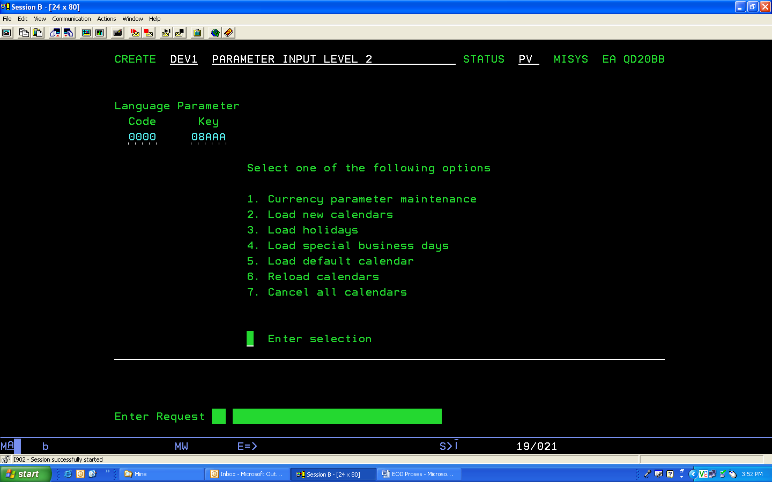
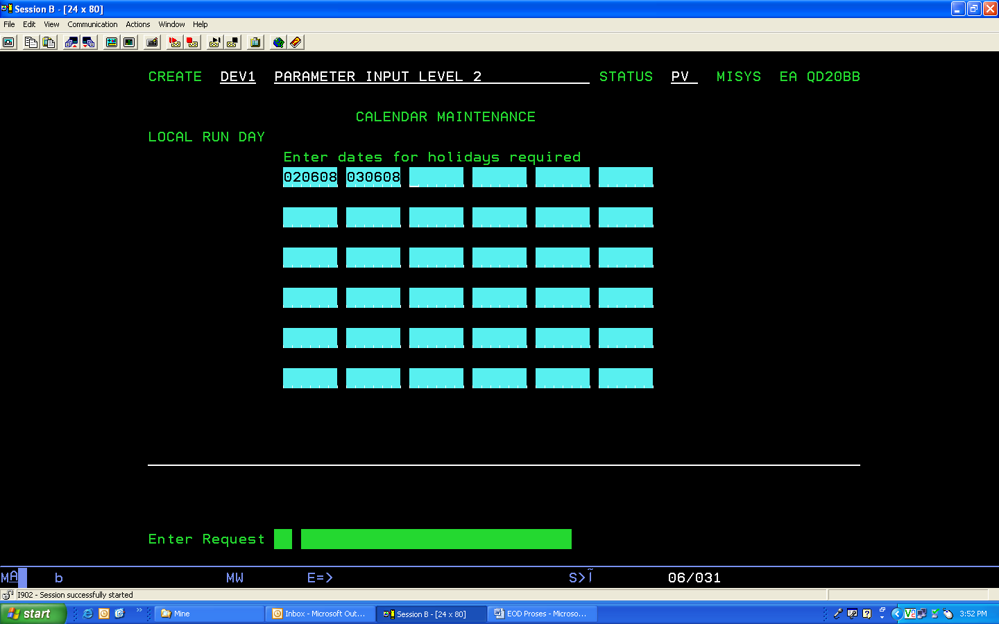
Suspend
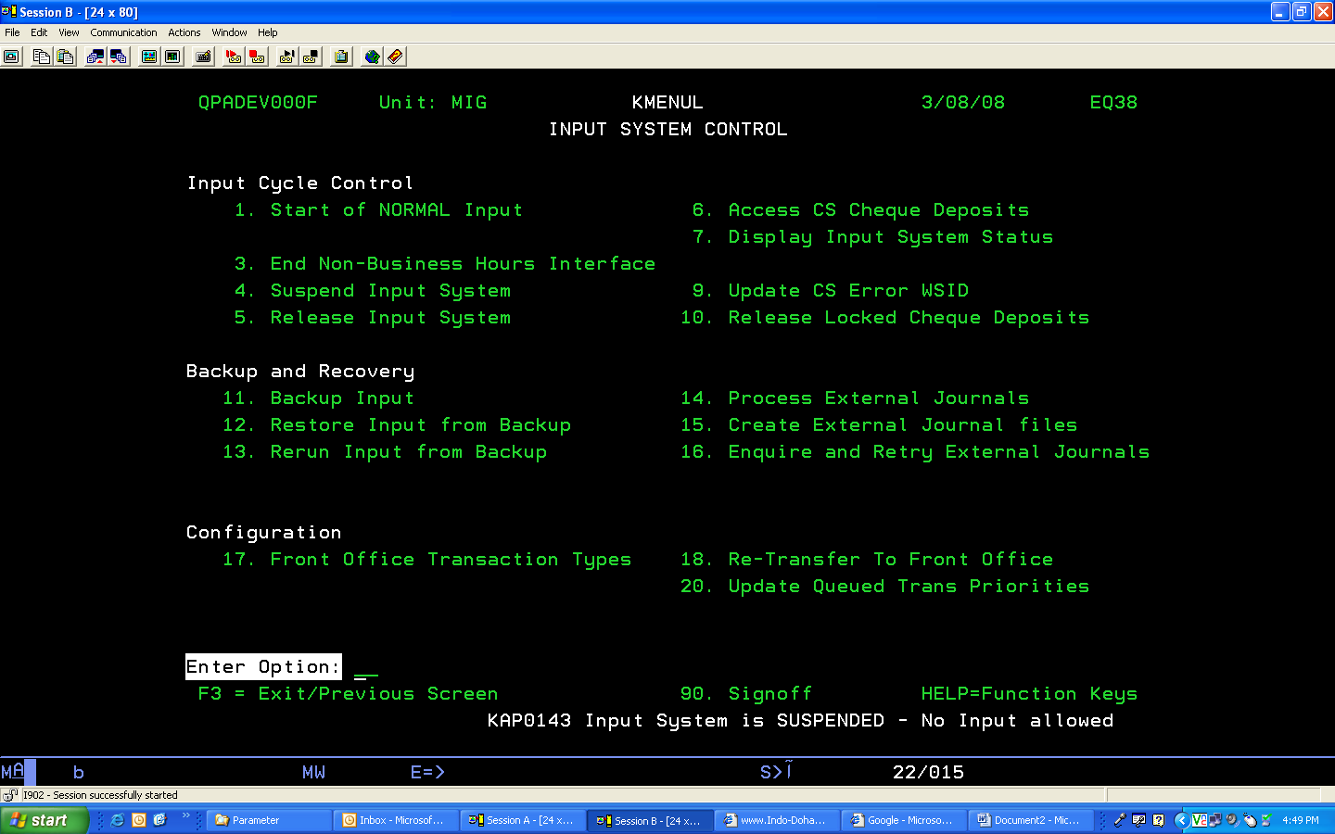
Kmenu1 option no.4 for start EOD
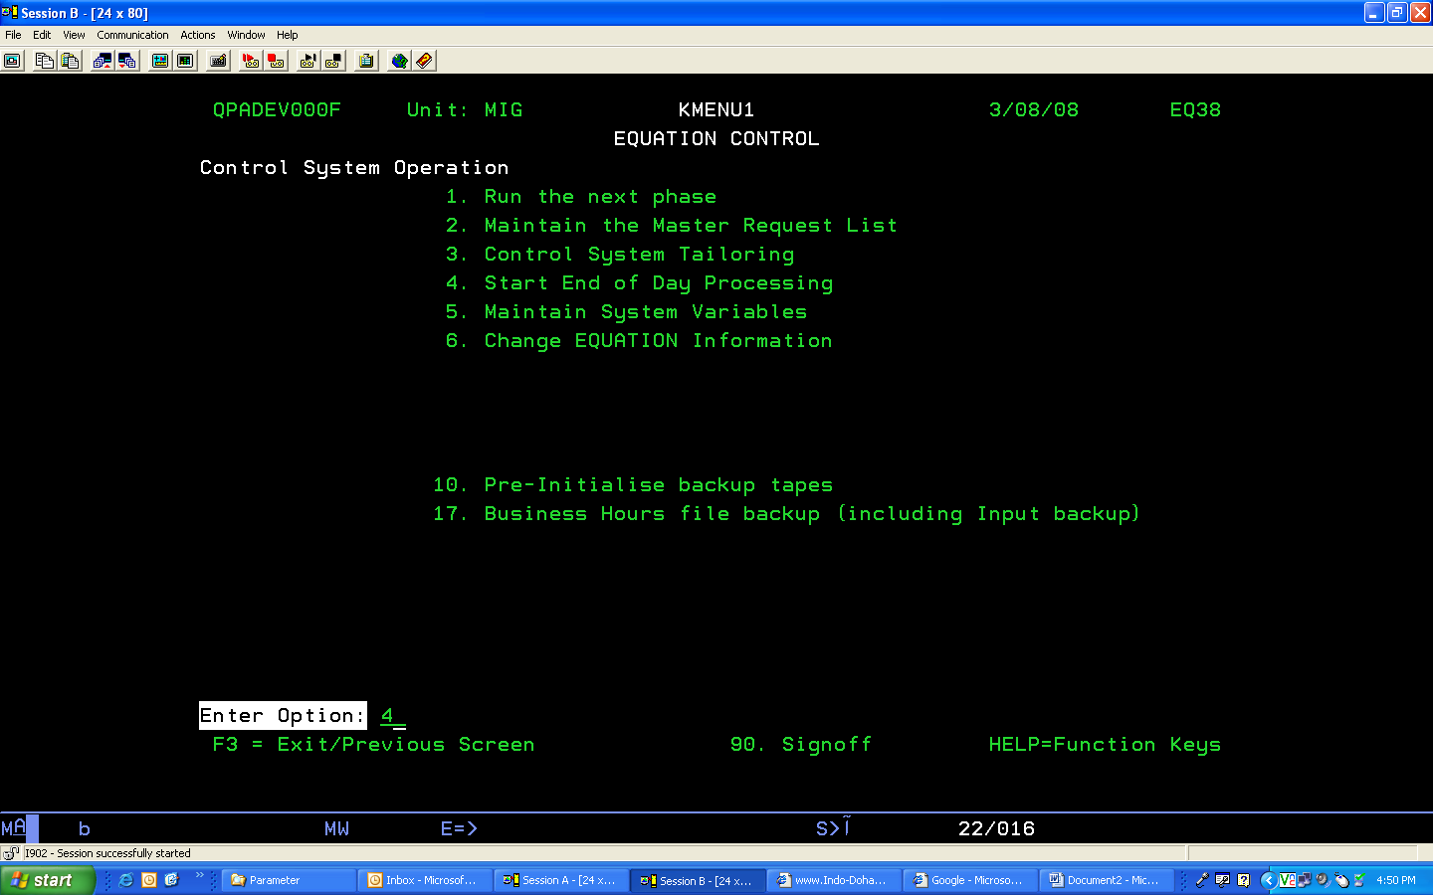
Enter
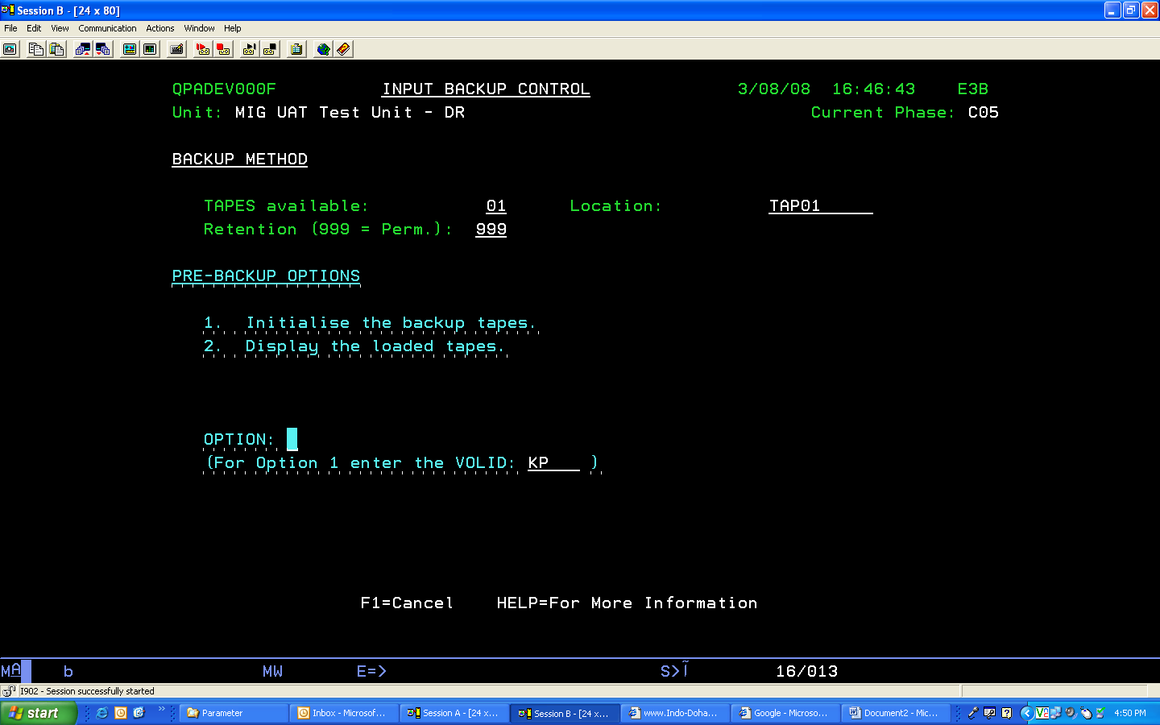
F1 to ignore
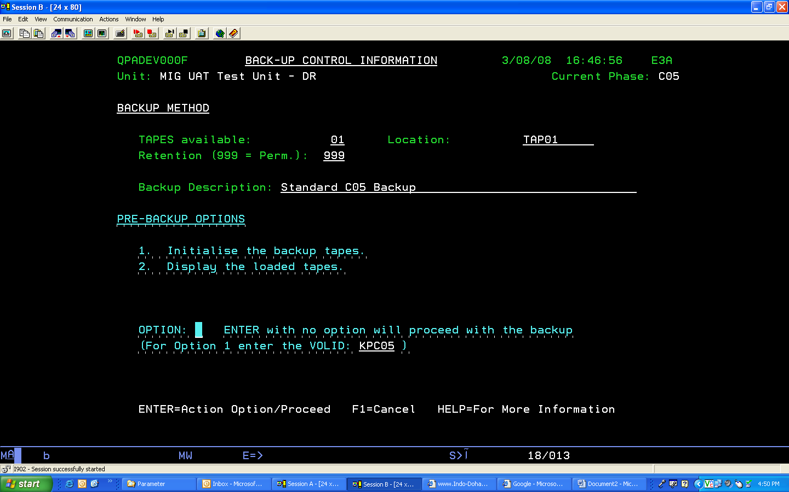F1 to ignore

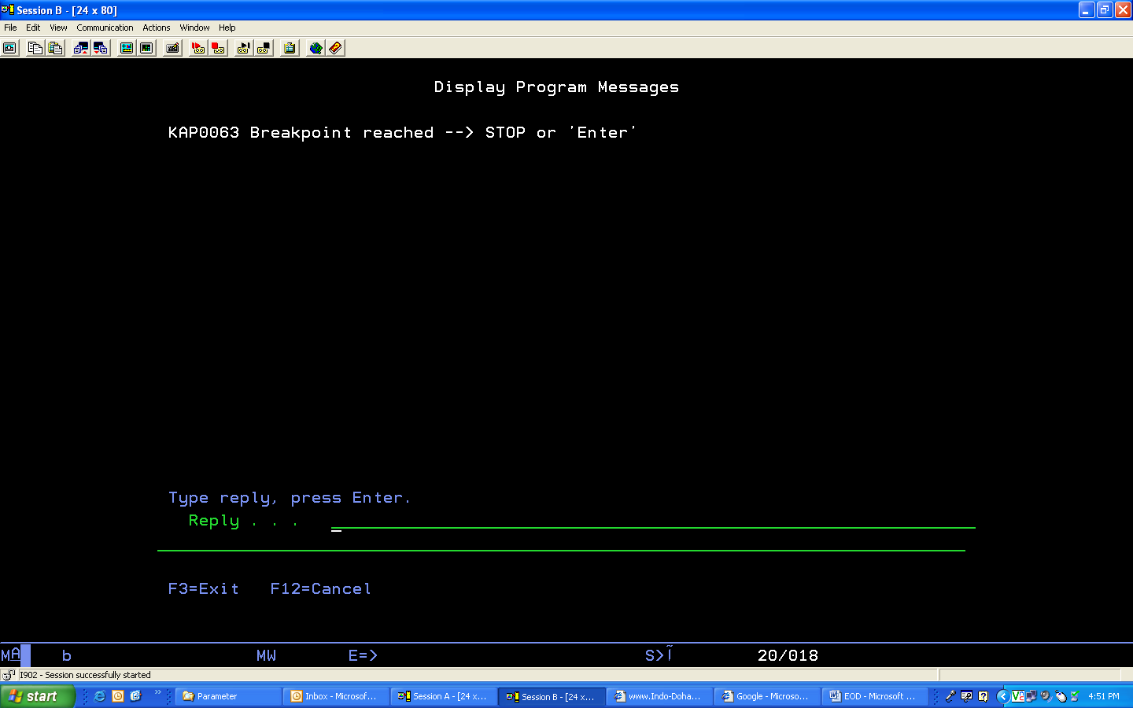
Enter
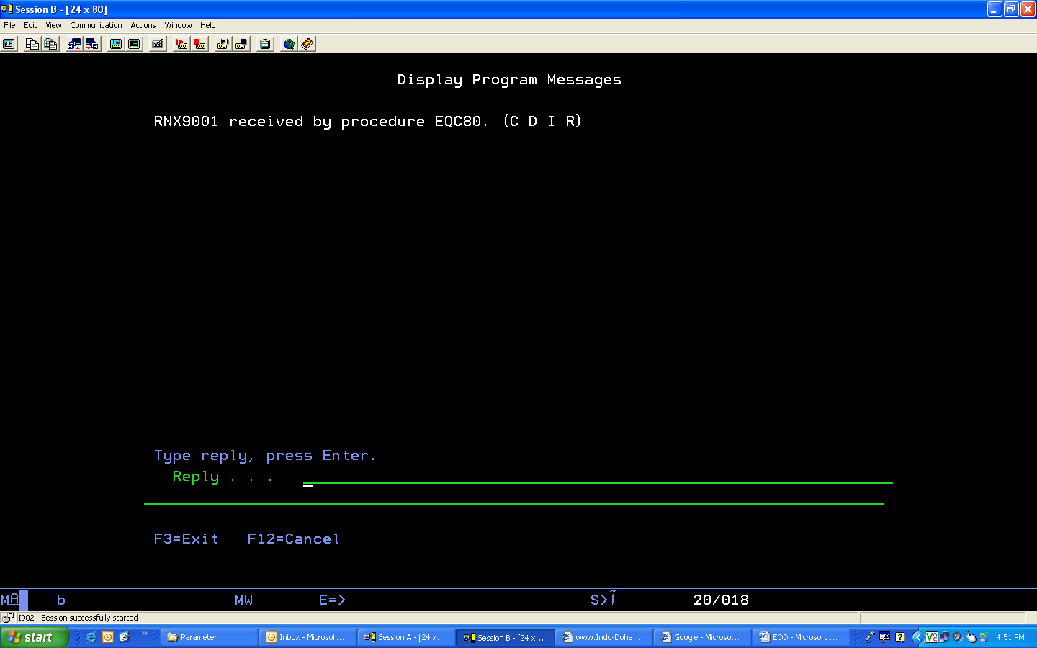
I to ignore

Auto Balancing –
- KMENU0
- 5. Maintain Major Processing Characteristics
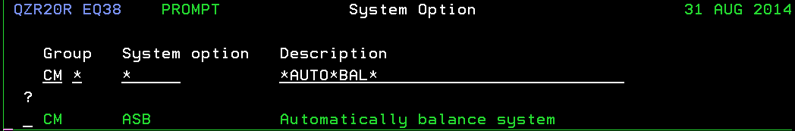
DONE

